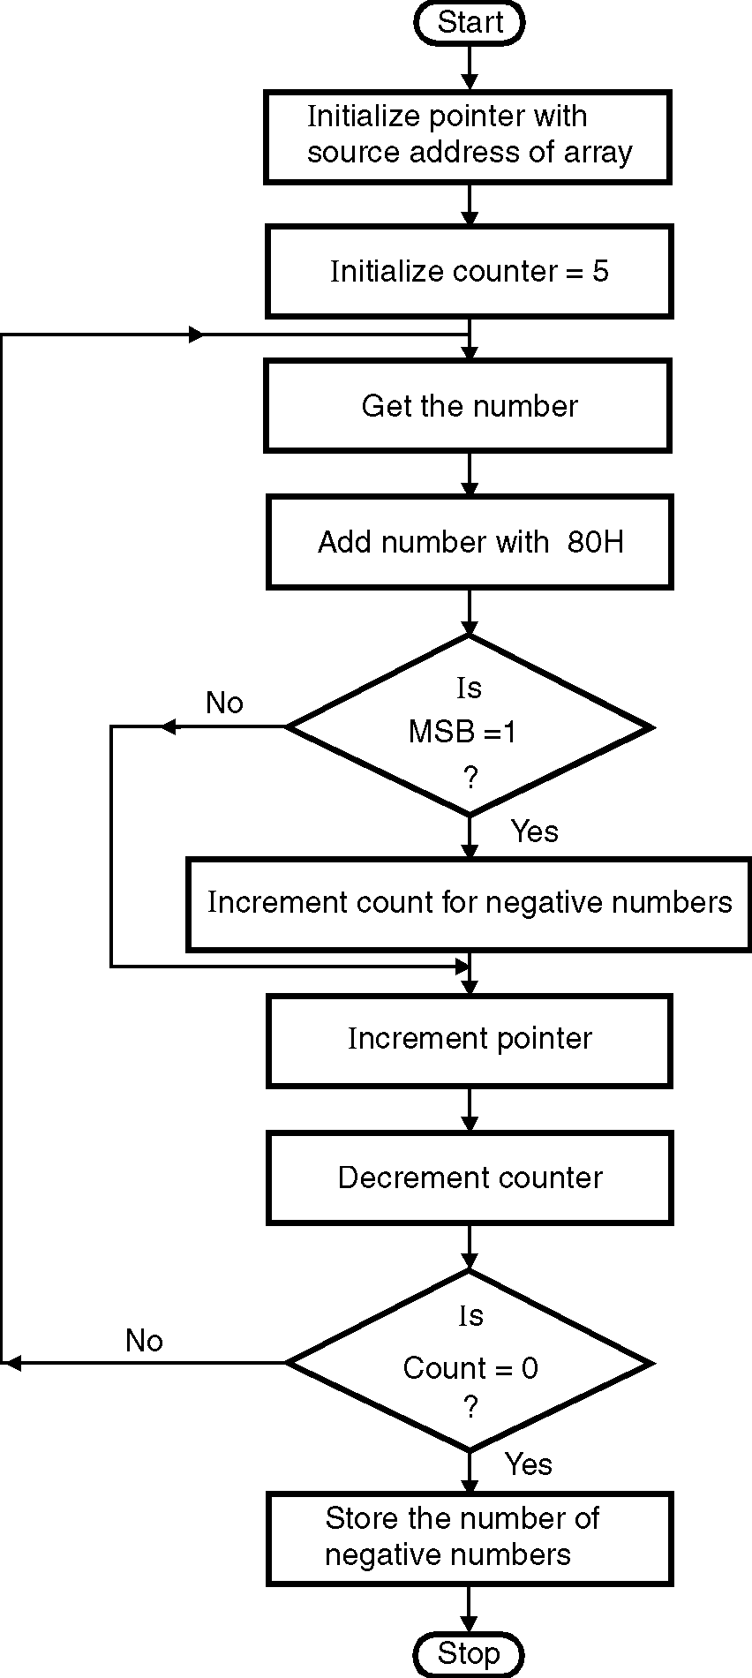
ØØ Explanation :
- We have an array of N numbers. For e.g. we initialize the count with 5.
- Also we initialize a pointer to point the elements in the array.
- We will check for the MSB. If the MSB of number is 1, the number is negative.
- Increment count for counting the negative numbers.
- Increment the pointer to point to the next element. Check if MSB is 1. Repeat process till all the numbers are scanned.
- Store the count of negative numbers.
ØØ Algorithm :
Step I : Initialize count for number of elements
Step II : Get the number.
Step III : AND the number with 80H.
Step IV : Check if MSB is 1. If yes, goto step V, else goto step VI.
Step V : Increment count for counting negative numbers.
Step VI : Increment pointer.
Step VII : Decrement count.
Step VIII : Check for count = 0. If yes, goto step IX else goto step III.
Step IX : Store the count for number of negative numbers.
Step X : Stop.
ØØ Flowchart : Refer flowchart 22.
ØØ Program :
Instruction Comment
LDA D000H
MOV C,A ; Initialize count
MVI B,00 ; Initialize the Negative number count = 0
LXI H,D001H ; Initialize pointer to array
BACK: MOV A,M ; Get the number Flowchart 22
ANI 80H ; Check for MSB
JZ SKIP ; Check if MSB = 1
INR B ; Increment negative number count
SKIP: INX H ; Increment pointer
DCR C ; Decrement count
JNZ BACK ; If count 0 repeat
MOV A, B
STA E000H ; Store the result
HLT ; Terminate program execution

